Lecture 02: Asking good questions and gathering evidence

Being Scientific

Dr. Gordon Wright

October 9, 2023

# Attendance QR Code HERE

## Key topics today

* The week ahead
* The research process you are beginning
* Effect sizes
* Lab preview - Literature, and making it your friend

## The week ahead

This week (week 2) you have your Personality Essay Tutorial

“Insert info”

title

Deadline 10am Friday x

Feedback on/by x

## Perennial CHIP topics

I want to briefly draw your attention to the third (final) piece of coursework for this module, the so-called ‘CHIP Learning Log’

The earlier we flag topics and introduce little glimmers of content, the easier that will be.

# 1 - What is Science?

## An amazing opportunity to consider this critical question while you do your Mini-Dissertation

Here is a thought-provoking initial overview - **Open Educational Resource**

Diener, E. (2022). Why science?. In R. Biswas-Diener & E. Diener (Eds), *Noba textbook series: Psychology.* Champaign, IL: DEF publishers. <http://noba.to/qu4abpzy>

# 2 - Artificial Intelligence - Promise or Peril?

## Last year, this was a fairly philosophical question

This year, you are probably using AI on a daily or weekly basis. I don’t need to give you 1980’s movie references to show you how we thought computers were going to take over the world and enslave the human race, we can just look out the window!

## CHIP topic approval process

Lectures identified with CHIP in the title e.g. weeks 16-20 [They change yearly!]

I am open to other topics, but they must fit the following brief, and be agreed in the Forum.

* A concept or debate within Psychology
* A historical issue or controversy
* A methodology or approach and its promises or limitations
* A distinctive or divisive topic
* A modern innovation or applied challenge

<https://www2.open.ac.uk/openlearn/CHIPs/>

# I can’t make bricks without clay!

## A psychologist? A scientist?

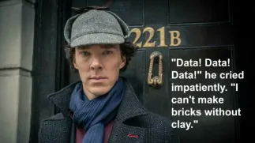

In this instance, Sherlock is talking about the need for data prior to solving a case. You can’t do science without data.

## Scientists base their ‘claims’ on EVIDENCE

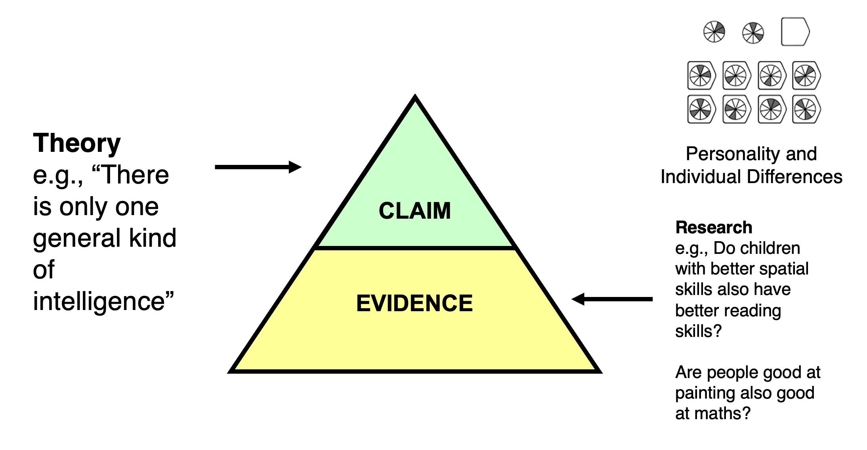

## Evidence quality = claim quality!

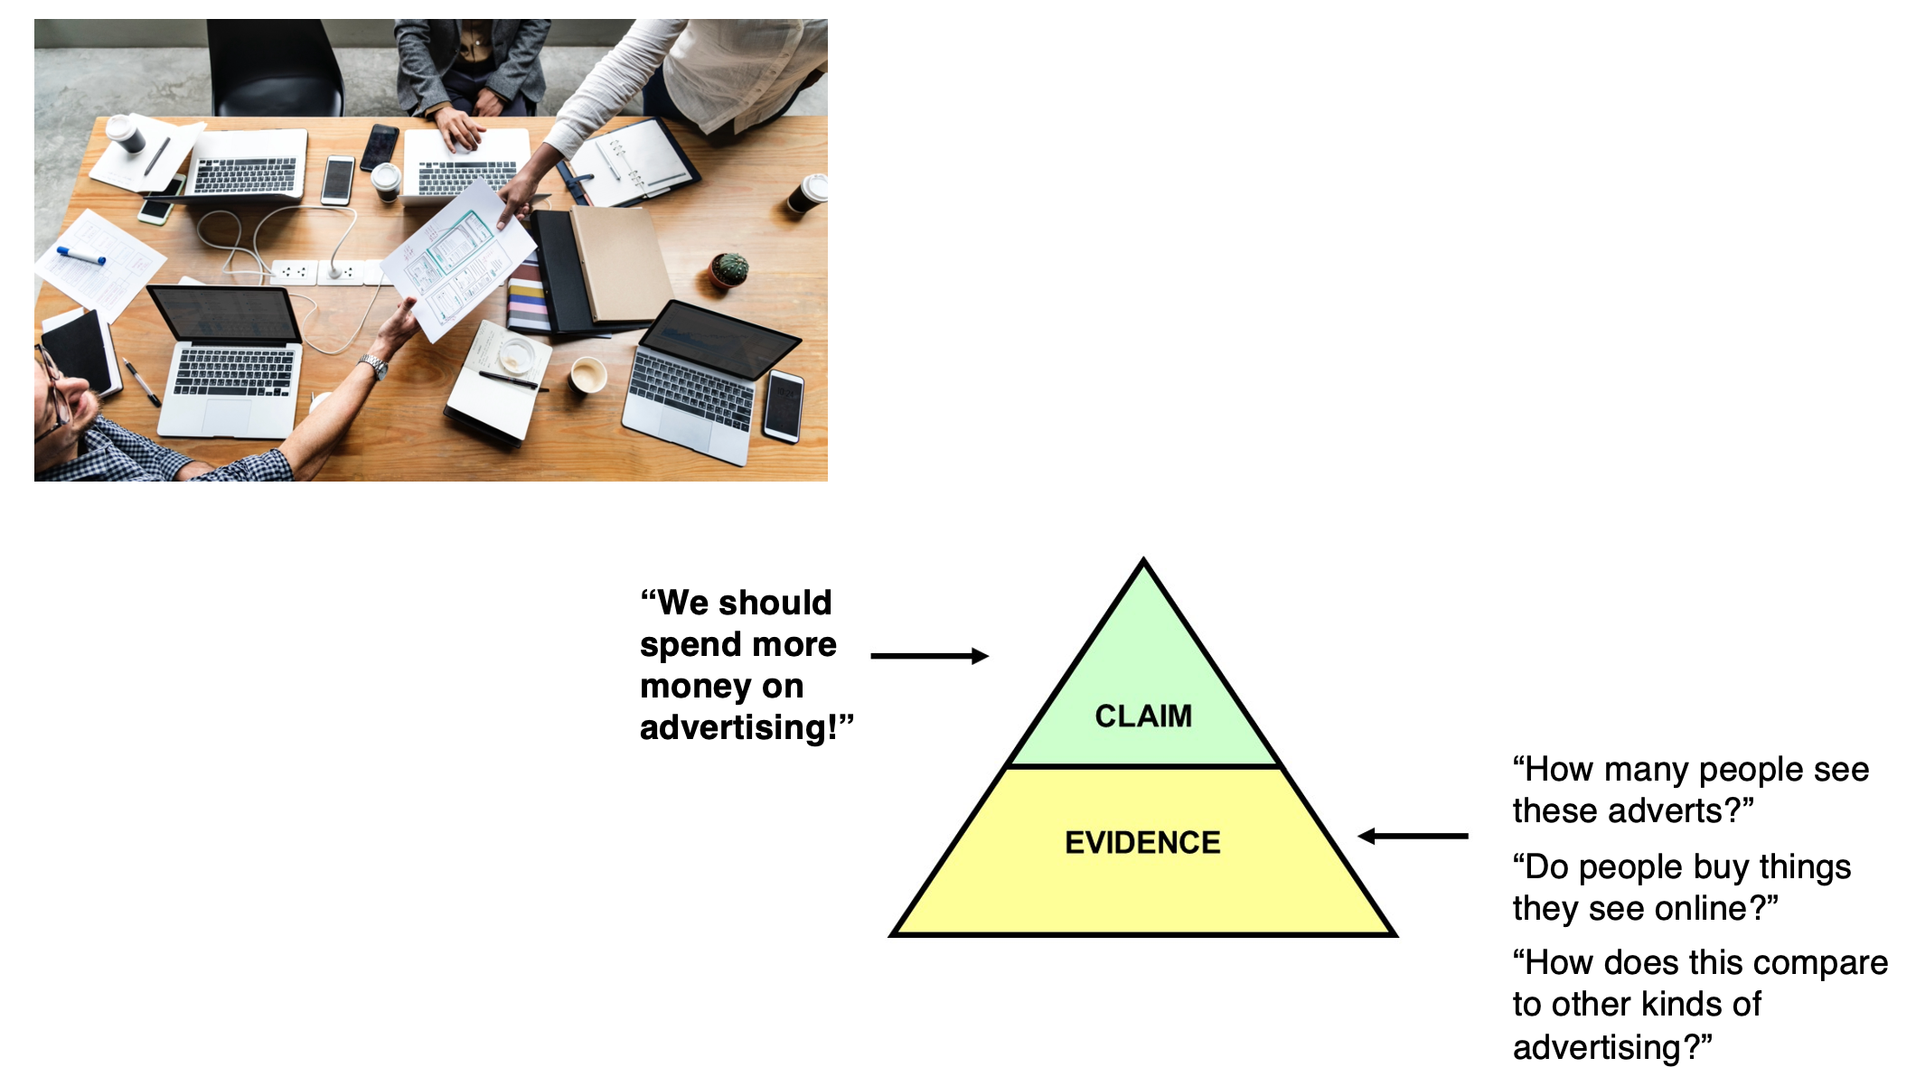

## It starts with a hypothesis

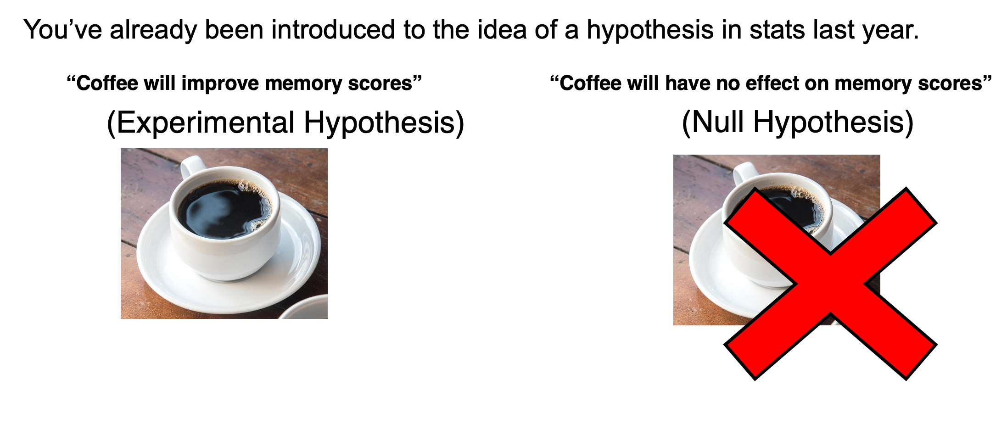

## recap on hypotheses

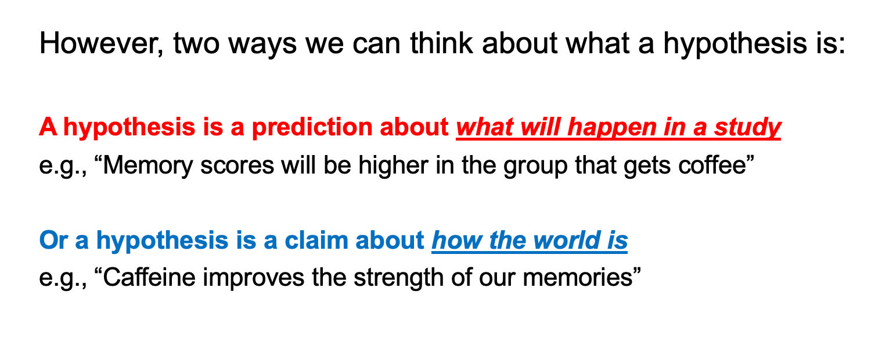

## The research process

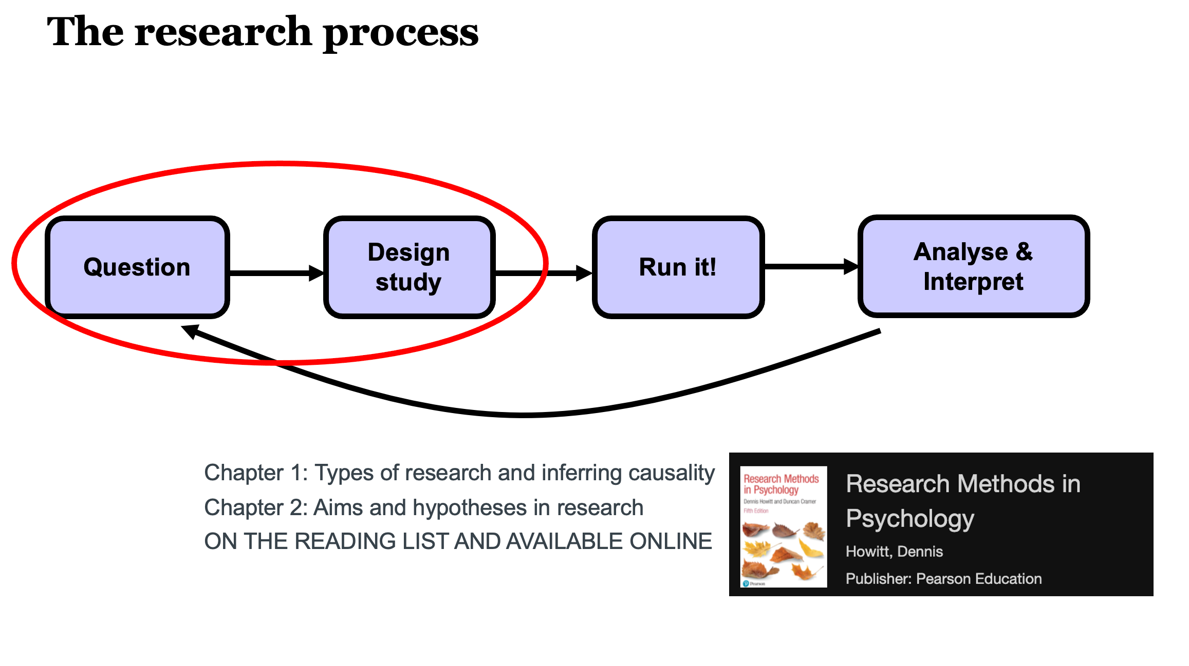

## The simplicity of an experiment

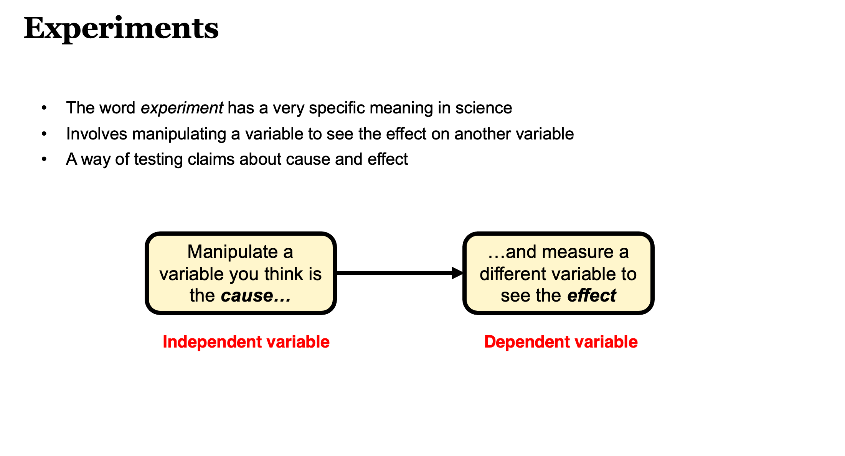

## Operationalisation

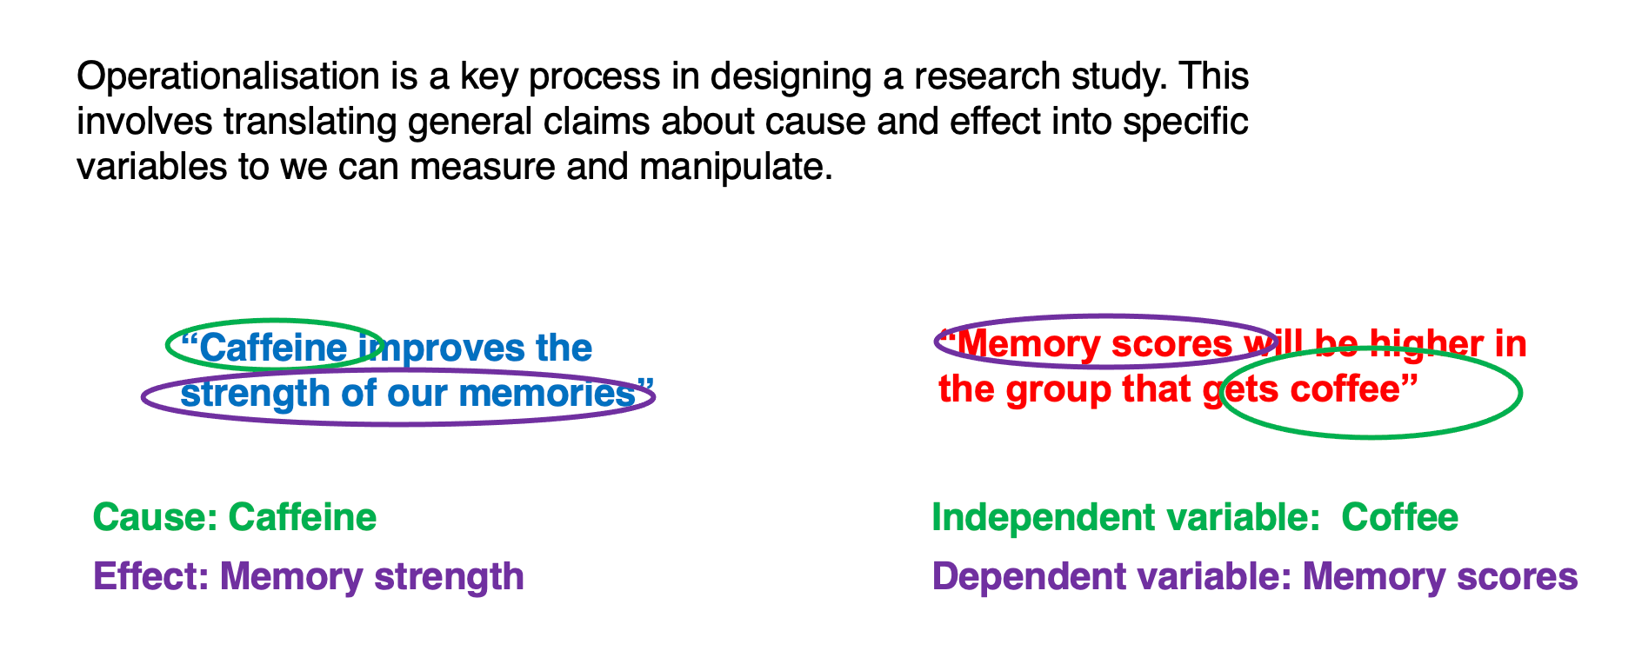

## The challenge of operationalisation

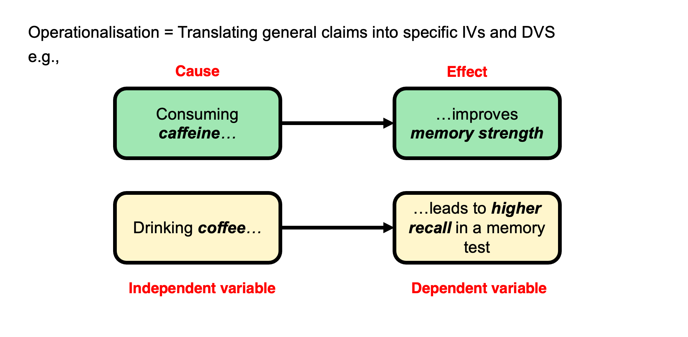

## A toy example

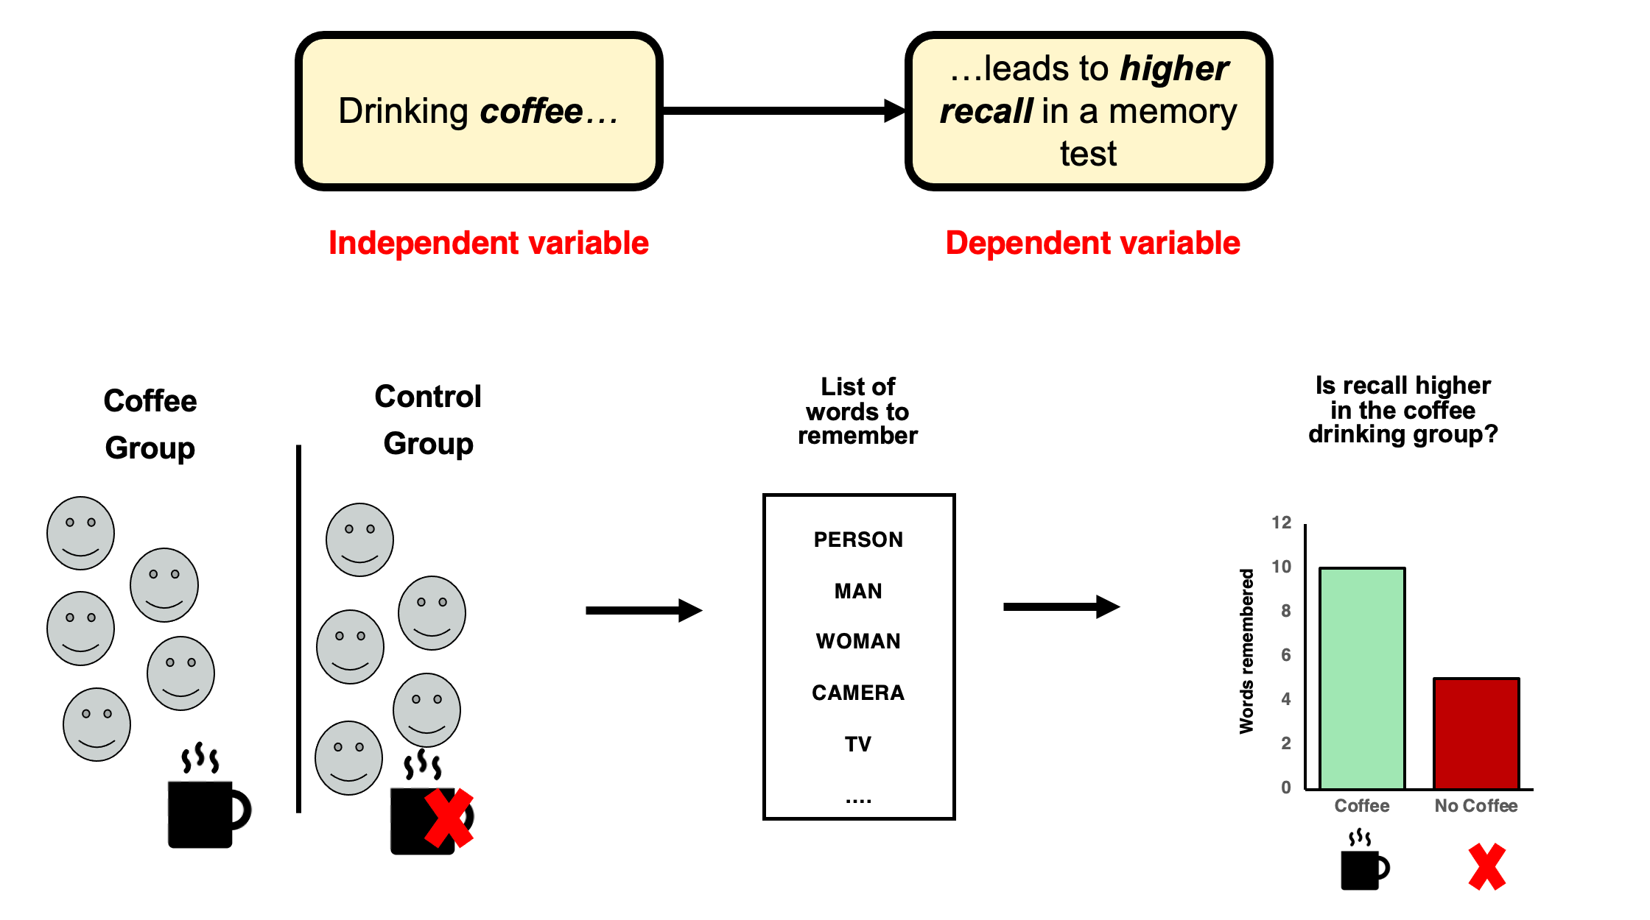

## Extraneous variables

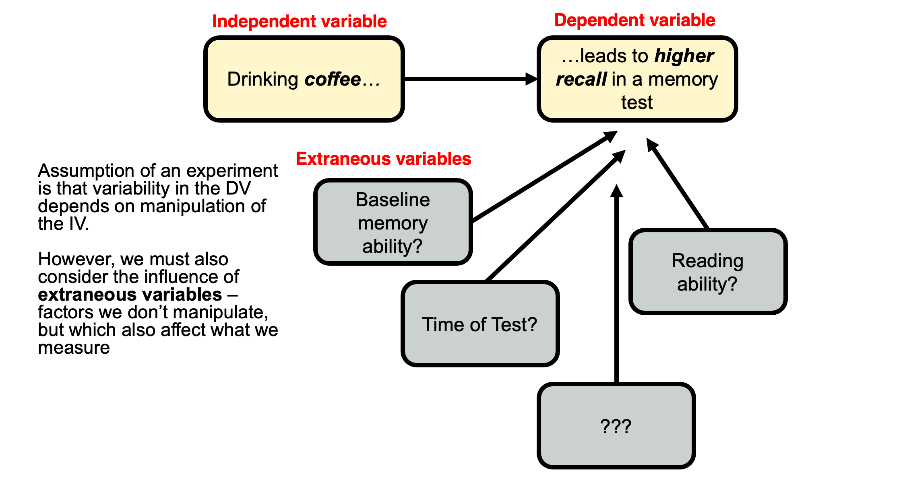

## Usually…

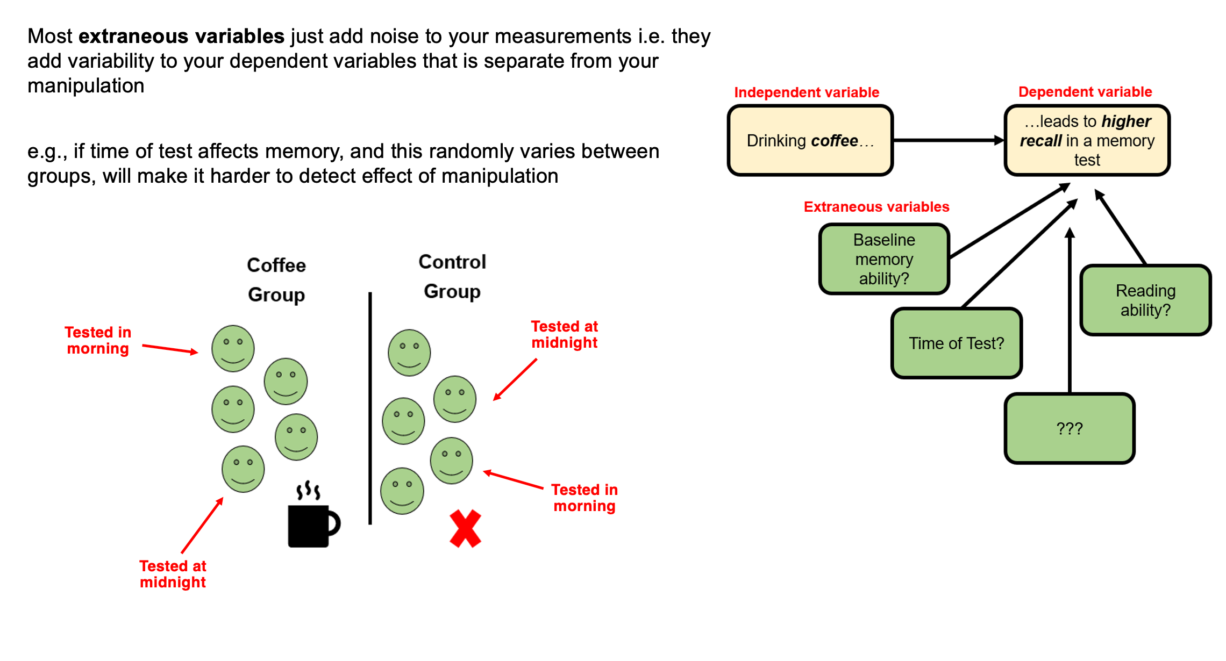

## but occasionally…

you hear of ‘confounds’ or ‘confounding variables’

A confounding variable is an extraneous variable that systematically varies with one of your independent variables. These are rare, but nothing can save the experiment.

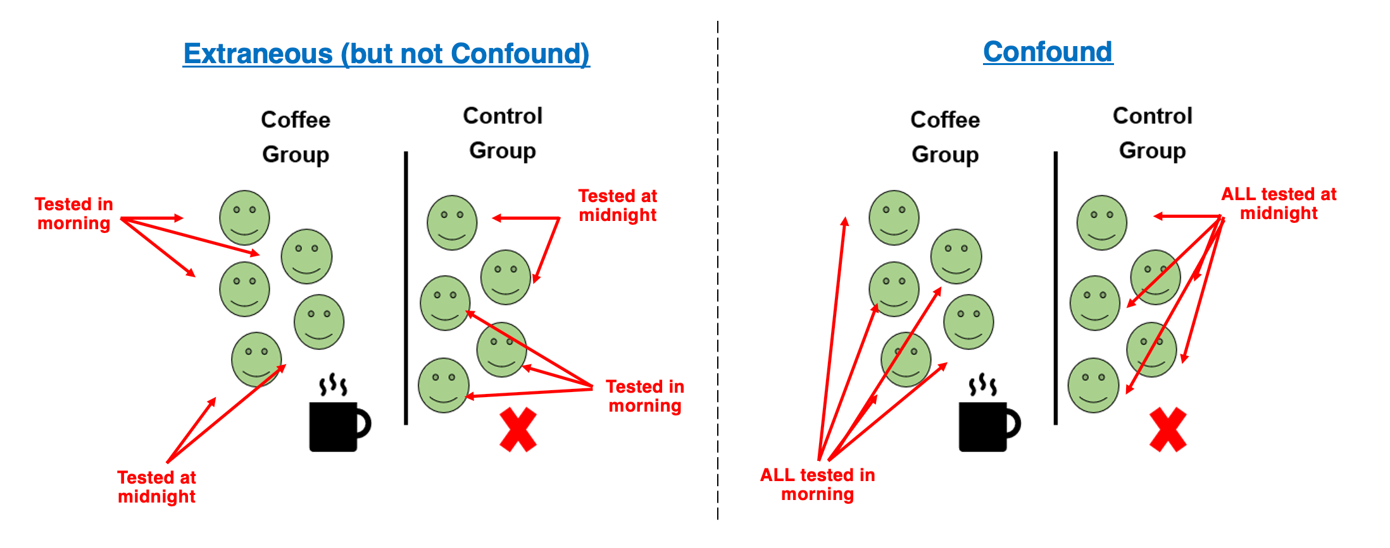

## An impossible interpretation

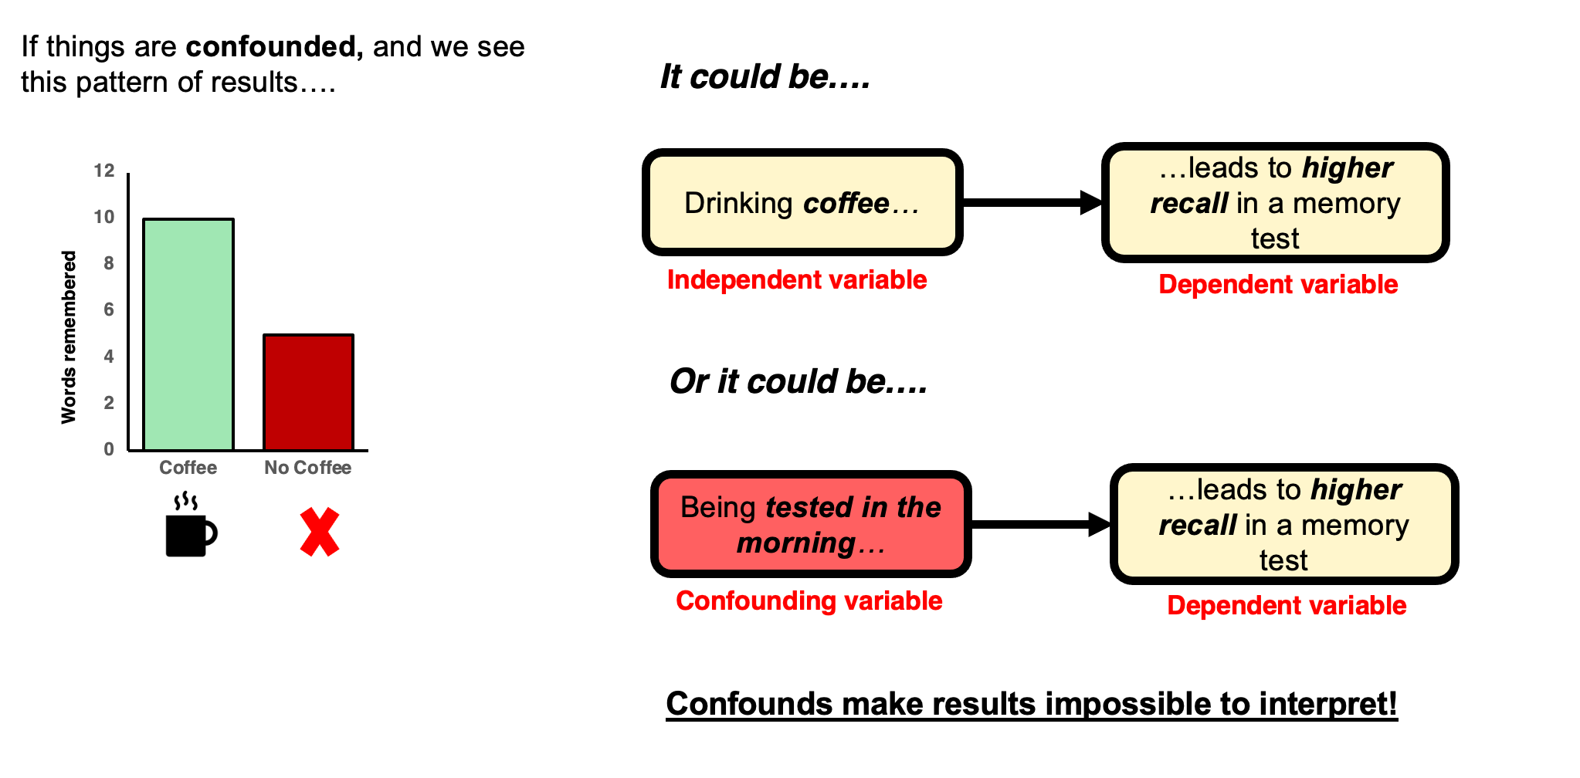

## Manipulations almost always introduce potential confounds

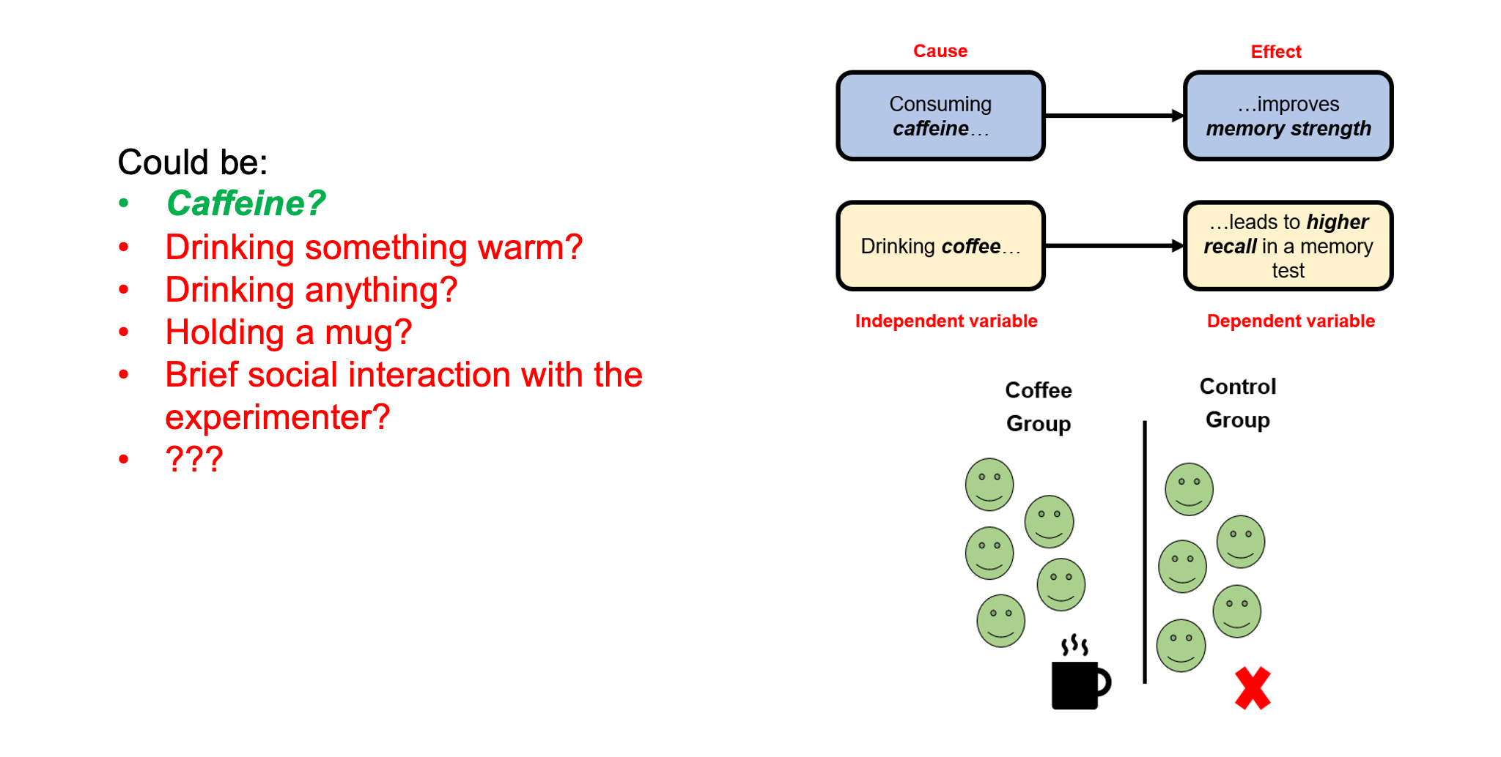

## Experimental skill + careful thought + piloting + randomness!

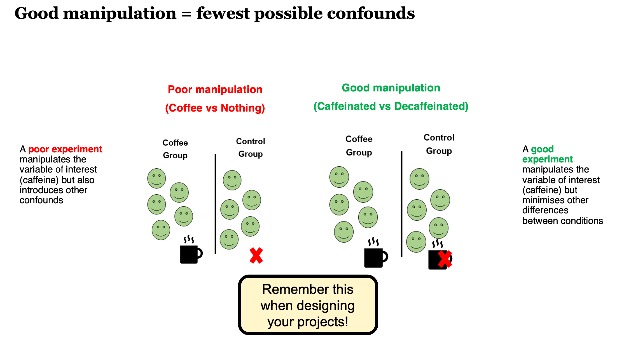

## The importance of operationalising your variables well

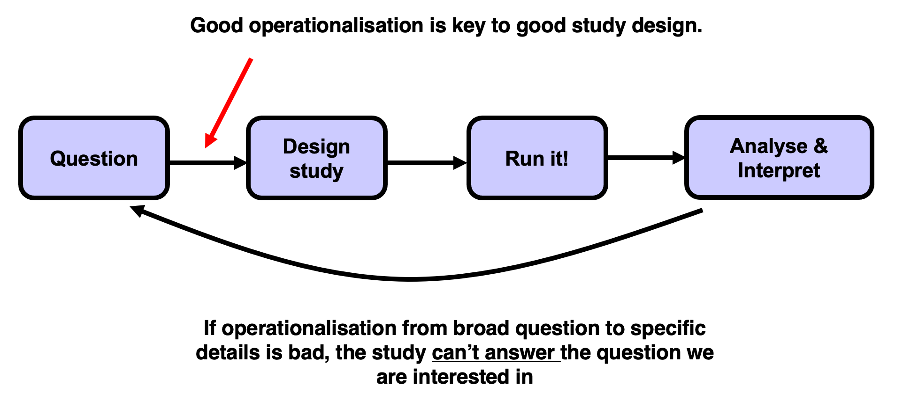

## Reading along

I highly recommend reading along with the general topics we cover in the first few weeks.

Research Methods in Psychology by Dennis Howitt and Duncan Cramer is excellent. Chapter 2 in that book (right at the top of the module reading list and [here](https://www.vlebooks.com/Product/Index/896220?page=0)) deals with Hypotheses and aims of research, essentially what we cover this week, and Chapter 1 deals with the basics and golden rules of research design and designing good experiments.

# Another interpretation of “I can’t make bricks without clay!”

## Garbage in, Garbage out

Last year someone selected a ‘target paper’ for their Critical Proposal [next week’s lecture topic] from a Sociology Journal - it presented a ‘thought experiment’.

No data, no methodology, no participants, no actual experiment.

How do you think they did?

## The literature you read will drive the quality of your output

* This applies to the study you design for your Mini-Dissertation
* This applies to your Module Essays
* This applies to your Critical Proposal
* It is NOT a question of QUANTITY
* It is very much a question of QUALITY
* It is a function of QUALITY and QUANTITY

# Lab 2 is about Literature Search and Management

# Effect Sizes

## A measure of the Effect (MOTE)

Effect sizes represent the magnitude of a relationship between variables, for example between a Manipulation and the Dependent Variable.

It’s like the ‘strength’ of your pill, or intervention, or manipulation.

Do not run an experiment that is designed to fail - you must believe a manipulation will have an ‘Effect’

If the manipulation works, then there will be an Effect

The Effect Size is just how big that visible effect was.

## Let’s imagine the simplest example possible

An independent t-test. Working Memory Capacity.

I have a magic pill to increase working memory capacity.

7 ± 2 is the Miller Law. Let’s read this as normal mean working memory capacity for a group of humans is mean 7 units with a standard deviation of 2 units.

Let’s say my pill was tried on a group of humans, and when we measured their mean working memory capacity it was 11 units with a standard deviation of 2 units. Wowsers!

That’s an effect size of d=2. Simply put, Cohen’s d is always presented in units equivalent to 1 standard deviation. So 11 is 2 SDs higher than 7.

[Calculating Effect Sizes (shinyapps.io)](https://katherinemwood.shinyapps.io/lakens_effect_sizes/)